Touch – 22 User Manual

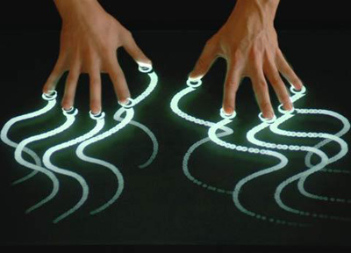

Table of Contents
- Introduction…………………………………………………………………………………………………………………..3
  - Purpose……………………………………………………………………………………………………………………3
  - Scope……………………………………………………………………………………………………………………….3
- Describing the System………………………………………………………………………………………………….…4
  - Key Features…………………………………………………………………………………………………………….4
  - Inventory………………………………………………………………………………………………………………….4
  - Environment…………………………………………………………………………………………………………….5
  - System Operations…………………………………………………………………………………………………..6
Appendix A – Bug Inventory……………………………………………………………………………………………………….8

Introduction

Purpose
The purpose of this user’s guide is to provide an introductory tutorial to the primary functions of Touch-22’s touch screen application software and how to use it.

Scope
This guide will only cover the operation of the software application e Touch-22 project group. It is by no means a comprehensive guide for the application, nor does it explain how the application works or internal data manipulations.
The software side of the scope of this guide only covers how to use the basic functions of the application in single touch scenarios. Although development has shown that the application will receive and work with multiple simultaneous touches, testing has not anticipated the responses to each and every possible multiple touch scenario. Due to this fact, this guide is somewhat incomplete with respect to the bug inventory.

Describing the System

Key Features
- Application responds to touches on the touch screen
- Application responds to simulations of touches using infrared emitting devices such as a remote control for a television
- Application responds to software touch simulations
- Application paints on a canvas according to user’s touch inputs
- Contains 10 different colors and 3 different brush sizes
- Is capable of quick saving and quick loading the state of the canvas at any point in time
- Contains an undo function to undo the last operation performed
- Contains a clear operation to clear the canvas back to being completely clear
- Contains a fill operation to fill an object with the chosen color
- Utilizes a shape and line function to draw a rectangle and a line respectively
- Has an erase function that restores the canvas to its original blank state at the touch event
- Employs a sample function that takes the color of the canvas at the selected point and makes it the selected color
- Can support multiple paint inputs simultaneously

Inventory
The software side of this project involves several components that run in parallel. First, the main screen (seen below at the right of Figure 1.1) consists of a toolbar at the top, a color bar at the right side, and a white canvas that dominates the middle of the window.
The toolbar at the top contains all the primary functions of the application. Most of these functions are activating by clicking once, while some require a position to be inputted (by touch) after pressing the button. These functions and how to activate each of them will be described in the section System Operations. The color bar on the right is used to select the color by which the user will paint on the canvas.

Environment
The environment of the application involves all the side processes that make the input process possible. There are two windows running in the background that transfer the touch events from the user to the canvas. These windows are non-interactive and are used completely for data processing. This window can be seen in the bottom right of Figure 1.1.
There is one other window which is the TUIO Simulator. This window has the capacity to simulate touch events without having the touch screen or even a webcam hooked up to the system. This is mainly used for debugging and testing purposes, but can fully emulate a running touch screen. This window has a large circle in the center and can be seen at the top left of Figure 1.1.

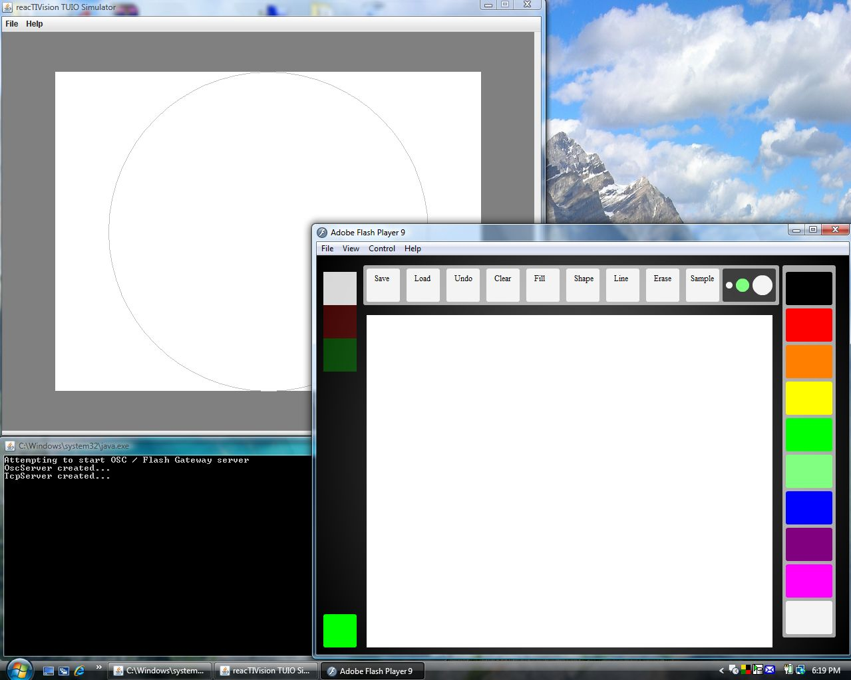
Figure 1.1 A screenshot of the running application with TUIO Touch Simulator
(Top Left) TUIO Touch Simulator, (Bottom Right) Paint Canvas, (Bottom Left) UDP Server and Data Transfer

System Operations
This section will describe the available functions of the application as well as a step by step process on how to use each operation.
The change color operation is performed by touching the screen within the color bar on a certain color. After doing so, any touches on the canvas will cause a point to be drawn on the canvas of that particular color.
The change brush size operation is performed by touching the top toolbar in the square with the three differently sized circles. Whichever circle you touch will determine the size of your brush. Touch the canvas again after changing the brush size to notice that the circle that appears when you touch the canvas is now the size that you have designated.
The save function is used by pressing the save button on the top toolbar. The system then saves a screenshot of the canvas at the time you incur the function, and that screenshot is loadable by using the load function. The user may draw on the canvas or perform other functions. Whenever the load function is used thereafter, the canvas will be loaded and will reflect exactly the canvas when the save function was last called.
The undo function reverses the effects of the last performed operation, reverting the canvas to a state as if it had never been performed. This is used by simply touching the undo box in the top toolbar. This does not include operations that do not affect the state of the canvas, such as the save operation.
The clear function clears the canvas to its original all white state. This operation is used by touching the clear box in the top toolbar. All paint operations that have been performed on the canvas are erased. This does not delete the saved canvas status using the save function.
The fill function is used by touching the fill button on the top toolbar and then touching the canvas at any point. The smallest block of consistent color that the touch event is located within will turn into the color that has been selected at that point. If the canvas is completely white, the canvas will entirely become the color that has been chosen.
The shape function is used by touching the shape button on the top toolbar. This product version of the application only allows the creation of a square shape to be created. After touching the shape button, the user touches the canvas at any point and a square is made at that location.
The line function is used by touching the line button on the top toolbar. The user then touches two points on the canvas and a line is immediately drawn between those two points with the thickness equal to the diameter of the chosen brush. This is equivalent to drawing a continuous series of brushstrokes between the two points.
The erase function is the exact reverse of painting. This is used by pressing the erase button on the top toolbar and touching the canvas anywhere. This will keep erasing until the user presses the erase button on the toolbar again, which stops the eraser from functioning.
The sample function is used by touching the toolbar on the sample button and then touching anywhere on the canvas. Wherever the touch is, the sample tool will determine the color at that position and transfer it to the brush. This means that after using the sample function, the brush will automatically paint the color that it has taken a sample of.

Appendix A: Bug Inventory

Bug #1: The Fill Function leaves an outline of the shape in its original color
This issue is still unresolved. Sometimes, when the fill function is used inside a shape, the shape will retain an outline of itself in its original color but everything inside will be converted to the new selected color.

Bug #2: The Zoom Function does not work
This issue is not so much of a bug as a removed function. There is no longer a button in the toolbar that represents the zoom function. There is commented and written code but has been tested and deemed unable to fulfill its use case.

Bug #3: The Select Function does not work
This is another function removed after the last revision to the project. There is also commented code in the project but there were a number of inexplicable reactions to inputs when using the operation that it was removed from the project.

